LIONS CENTENNIAL CELEBRATIONS recommended hotels
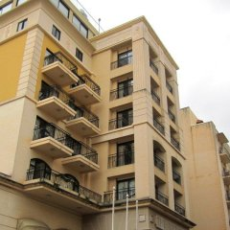
Victoria Hotel 4 star
Booking link https://booking.hotelrez.co.uk/?Hotel=69228&promo=lions
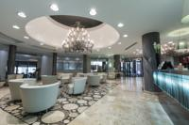

Palace Hotel 5 star
TP: https://booking.hotelrez.co.uk/?Hotel=69019&promo=lions

